Pack & Send just keeps growing
By Alan Bunce
January 25, 2013
A business which launched in Reading in the depths of the recession now has nine centres nationwide, employs 40 people and reports increasing sales every year.
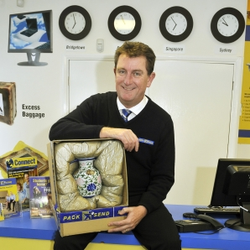
In just three years Pack & Send has grown from a single unit in King’s Road to a nationwide network and plans to keep growing to have more than 200 centres.
The recession-busting firm packs items, often awkward and difficult ones, for people who want them transported anywhere around the world.
It had been running in Australia for some years when former boss of Betterware Mike Ryan was asked to consider starting a UK operation.
Together with Tony Fowles, who left a senior role at Safestore Plc to join him, and former board member of Allied Domeq Martyn Grealey, he went Down Under to learn more.
Mr Ryan, who lives in Caversham, said: “We started it very soon after we sold the Betterware business.
“We were asked if we were interested in having a look at bringing it to the UK.
“We went to Sydney, met the team and went round the Australian stores and fell in love with it.
“It’s a great concept, a great business.”
But he admits starting in the midst of recession made it tough although there has been little to hold back the company’s growth in the UK.
He said: “Things have been going really well.
“When we first started most people thought we were crazy at the beginning of the downturn but we’ve gone through it, hopefully, eventually, we will come out of it, but the business has grown very nicely.
“The climate we have been in is the worst I have ever seen in my career.
“It says a lot about the business that while it has been challenging, with the demand for the service we provide, every year we have been able to grow our sales.
“I think there are a lot of companies who would be happy with our sales growth.”
Visits to the firm’s website have more than doubled in the last year and enquiries by phone and online have gone up 240 per cent.
The biggest challenge he said has been the logistics of starting from scratch when he was used to the bigger and better-funded corporate environment.
He said: “If you want anything done, there is yourself and a couple of others.
“We don’t have a large IT team or a large HR team, or this team or that team, if you want a cup of tea you have to make it yourself.” For more information visit www.packsend.co.uk

